Project Development Phase
In the development phase for streamlining ticket assignment, the primary objective is to transition from manual, error-prone routing to an automated, rule-based system that balances agent workloads and reduces response times.
Key Development Phases
A typical technical implementation, such as within ServiceNow, follows these structured phases:
- Requirement Analysis & System Design: Identify user needs, volume of requests per category, and existing service level agreements (SLAs).
- User, Group, and Role Setup: Create distinct support groups (e.g., "Software," "Hardware") and assign users to them with specific roles to define access privileges.
- Core Data Structure (Table Creation): Develop the underlying database or tables to store ticket details, issue types, assigned groups, and status.
- Access Control (ACL) Configuration: Implement security rules and Access Control Lists to ensure only authorized personnel can view or modify specific tickets.
- Automation Flow Implementation: Build the logic that automatically routes tickets. This often uses "Flow Designers" to assign tickets based on issue types, such as routing "Network" issues to the "IT Infrastructure" team.
- Testing & Validation: Conduct unit and integration tests to verify that tickets trigger the correct rules and are assigned to the right agents
Strategic Assignment Methods
During development, you must choose the logic that governs how tickets are distributed among available agents:
- Round Robin: Tickets cycle through a team list to ensure equal distribution.
- Skill-Based Routing: Assigns tickets based on an agent's specific expertise (e.g., billing, technical).
- Load Balancing/Throttle Limits: Automatically checks agent availability and current ticket volume to prevent overload.
Essential Development Components
- Categorization & Tagging: Standardize ticket fields (e.g., "Unable to login," "Hardware failure") so the automation engine can read them.
- SLA Integration: Build in automated alerts for tickets approaching their deadline to prioritize them before they breach agreements.
- Self-Service Portals: Develop a front-end where users can submit tickets, which significantly reduces the manual triage burden.
Detailed step-by-step setup for these systems can be found on documentation platforms like the ServiceNow Community or Intercom Learning Center.
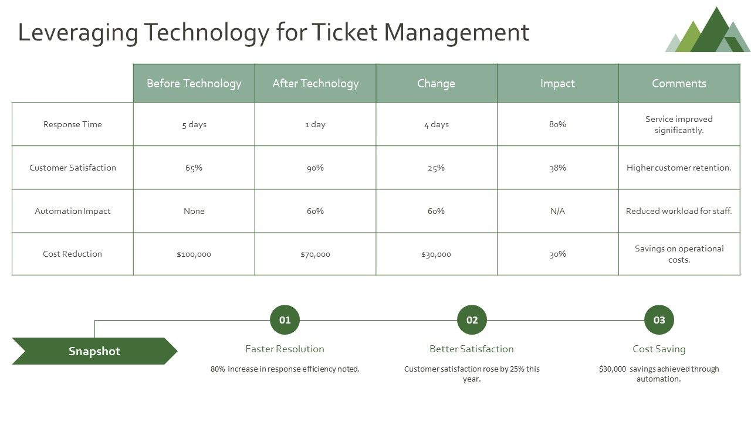

Would you like to focus on the technical configuration for a specific platform like ServiceNow, or should we look into the KPIs used to measure this project's success?

